Project Design Phase-I
Solution Architecture

Date | 28 October 2026
Team ID | en25cs3010357
Project Name | Electric Vehicle (EV) Market Analysis & Performance Insights
Maximum Marks | 4 Marks

Solution Architecture:
Solution architecture is a complex process – with many sub-processes – that bridges the gap between business problems and technology solutions. Its goals are to:
- Find the best tech solution to solve existing business problems.
- Describe the structure, characteristics, behavior, and other aspects of the software to project stakeholders.
- Define features, development phases, and solution requirements.
- Provide specifications according to which the solution is defined, managed, and delivered.

Sample Solution Architecture Diagram:
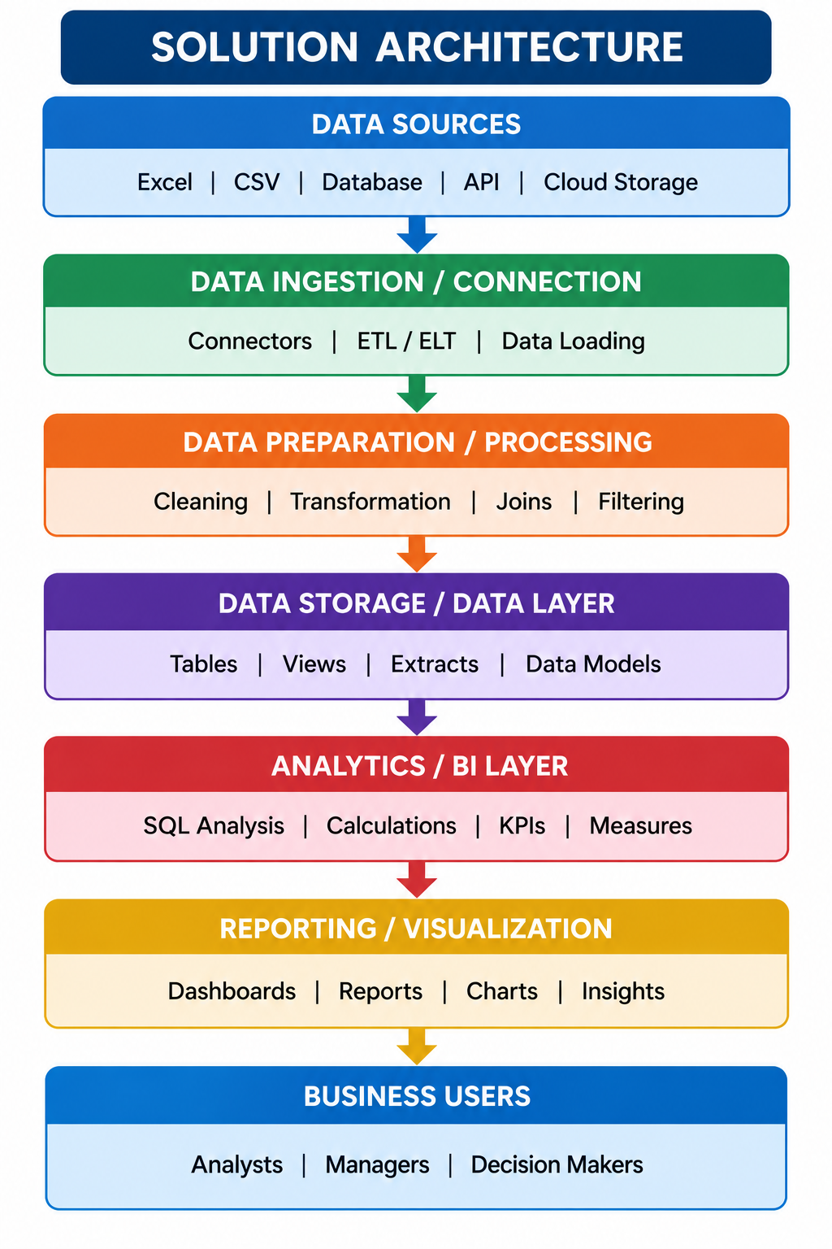

Component Description Table
Component Name | Description / Role in Architecture | Technology Used

Implemented solution architecture
Source: EV market CSV (37 source fields). Ingestion: Tableau Desktop direct file connection. Processing: Tableau dimensions, measures, aggregations and filters. Presentation: nine worksheets → two dashboards → Tableau Story. Distribution: Tableau Public URLs. No SQL server, Snowflake warehouse or backend application was implemented.

